Lab 4
Shlomi Domnenko – 318643640

Lab Environment
Using deterlab as cloud virtual machines:
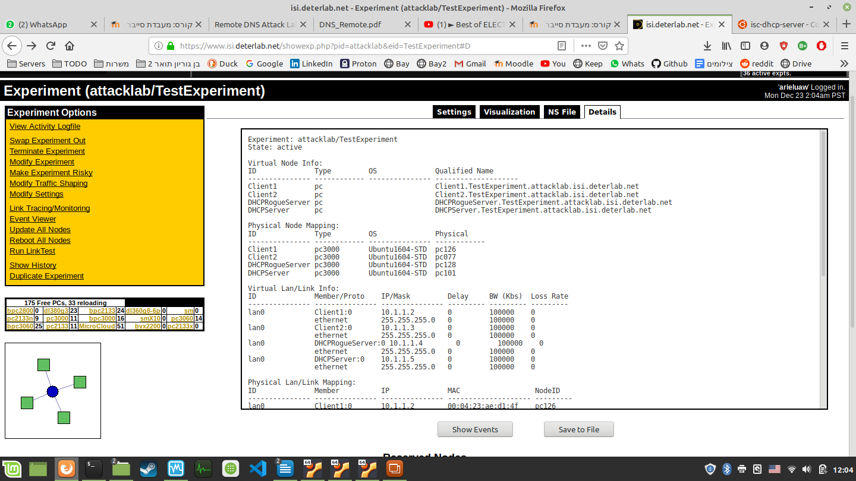
Addresses:
Client1.TestExperiment.attacklab.isi.deterlab.net
Client2.TestExperiment.attacklab.isi.deterlab.net
DHCPRogueServer.TestExperiment.attacklab.isi.deterlab.net
DHCPServer.TestExperiment.attacklab.isi.deterlab.net

NS File:

# Generated by NetlabClient

set ns [new Simulator]
source tb_compat.tcl

# Nodes
set Client1 [$ns node]
set Client2 [$ns node]
set DHCPRogueServer [$ns node]
set DHCPServer [$ns node]

# Lans
set lan0 [$ns make-lan "$Client1 $Client2 $DHCPRogueServer $DHCPServer" 100000kb 0ms]

$ns rtproto Static
$ns run

# NetlabClient generated file ends here.

# Finished at: Mon Dec 23 11:52:48 IST 2019

Lab Visualization

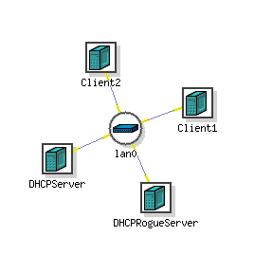
The middle node is a switch for the lan0 network

How to use the machines
- SSH into arieluaw@users.isi.deterlab.net
  - The password is: “Cyberlab19”
- Then, you can SSH into the machines, for example:
  - DHCPServer.TestExperiment.attacklab.isi.deterlab.net
  - The password is: “Cyberlab19”

Tasks
- SSH into DHCPServer, Create DHCP server (Download stuff)
- Test DHCP server by using client to get IP
- After the test is successful, create DHCP starvation attack
- Use the DHCPRogueServer to run the malicious script
- Test the attack by using diffirent client to get diffirent IP. The attack is successful when the client doesn’t get IP.

Setting up DHCP server

This is TMUX of the client1. On the left, we see tshark running inside client, and it shows DHCP discover, DHCP offer, DHCP request, DHCP ack:
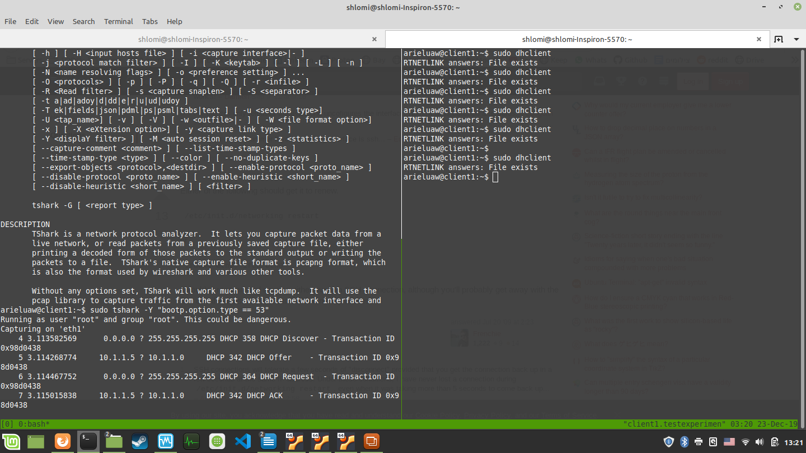

On the right, we use dhclient to renew our ip.

IP’s of other machines
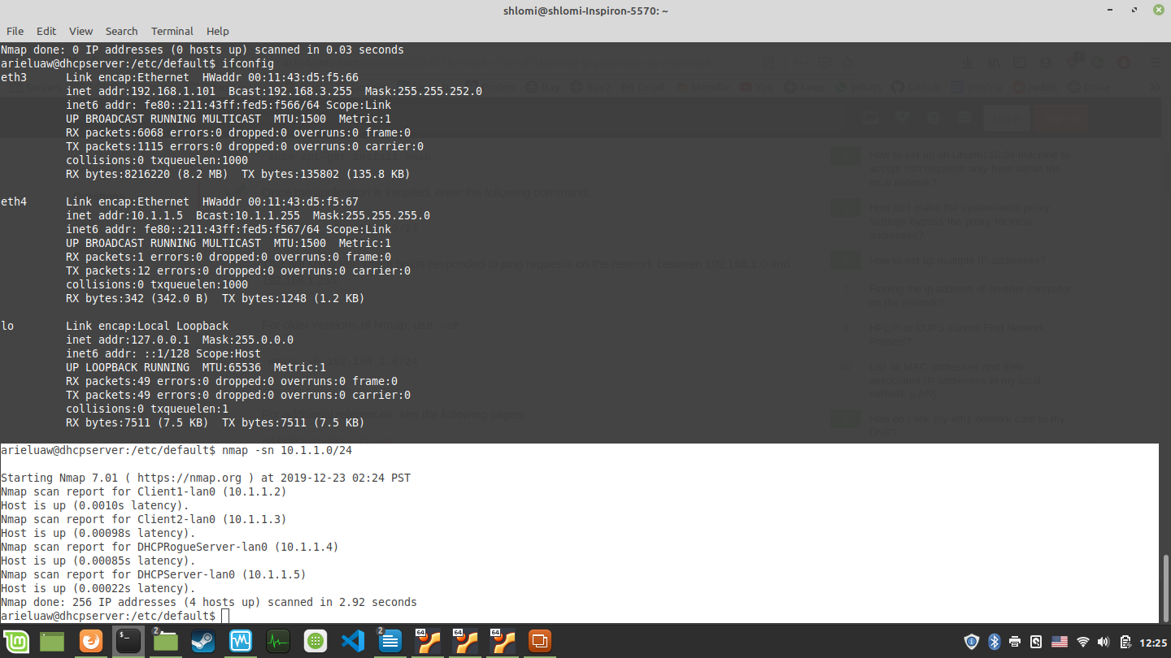

Setting up VirtualBox lab enrivonment
One machine is the attacker and another is the DHCP server, both are Ubuntu 18.04.
Both of them are using Bridged Adapter in order to have internet and can talk to each other. (The DHCP won’t have internet after it is running, because it uses the adapter to serve)
The server is running isc-dhcp-server service, configuration file:
#/etc/dhcp/dhcpd.conf

option domain-name "example.org";
option domain-name-servers ns1.example.org, ns2.example.org;

default-lease-time 600;
max-lease-time 7200;
###########################################
option subnet-mask 255.255.255.0;
option broadcast-address 192.168.10.255;
option routers 192.168.10.254;
subnet 192.168.10.0 netmask 255.255.255.0 {
range 192.168.10.10 192.168.10.100;
range 192.168.10.150 192.168.10.200;
}
###########################################
ddns-update-style none;

After installing (with apt install isc-dhcp-server) and configuring we also need to change the adapter settings. The virtualbox machine has adapter called enp0s3 which has old IP address so we release it by using: sudo dhclient -r and setup static ip: 192.168.10.50
Let’s see the leases:
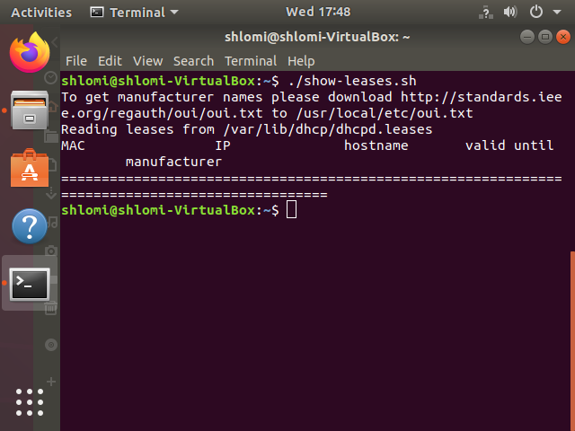
At first our DHCP server doesn’t have leases:

Then we attack:

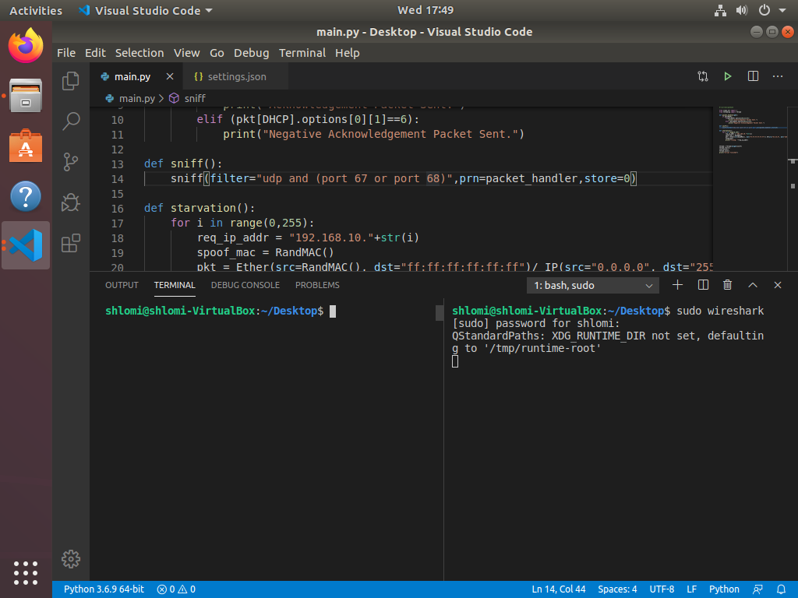
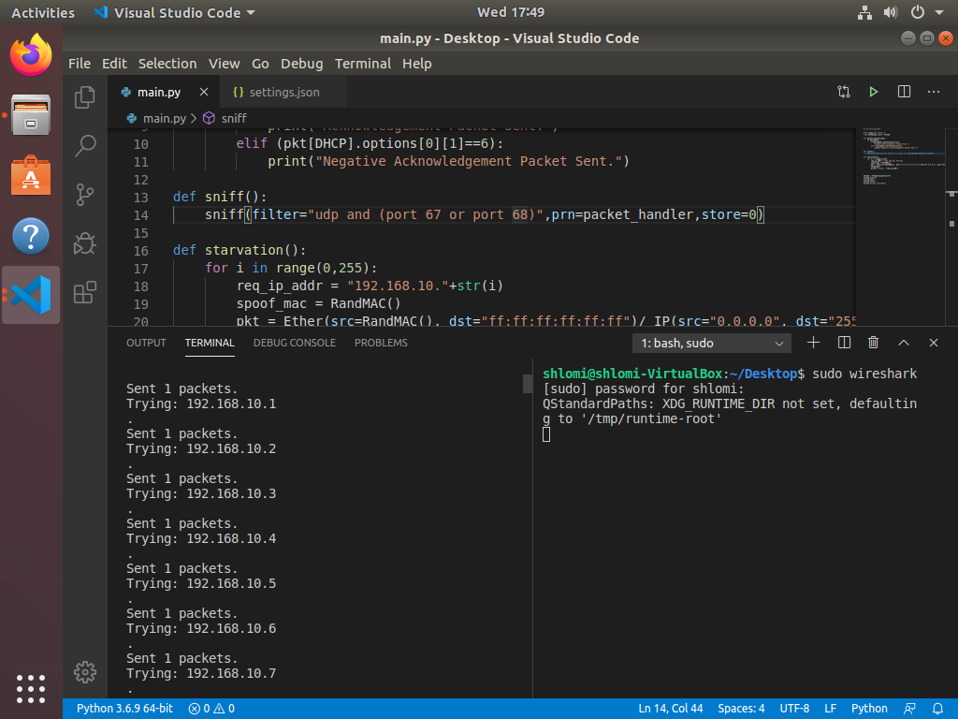

Wireshark showing attack:

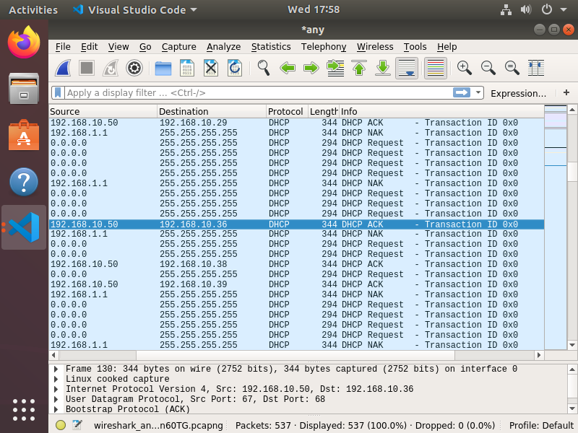

And the server has leases:

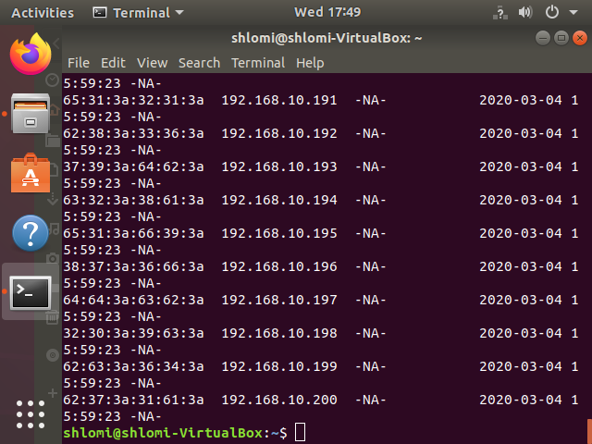
Which means when another client wants to get IP lease he canno’t and the server is starved out of IPs to give.

